September 7, 2016

**IT351-1603B-01: Advance Java Programming**

**User Manual**

**Duane Osburn**

Table of Contents

Introduction 3

How it works 3

Pre-Requisites 4

Setting up MySQL 4

Setting up the IT351sales Database 6

Load Application into NetBeans 8

Using the application 9

View of Create Record window 10

View of Edit Record window 11

View of View Record window 12

Exit the application 12

# Introduction

This user manual takes you through the process of setting up the environment and the databases that are necessary to run the IT351jsf project. This project makes use of the following:

* MySql Database
* Netbeans
  + IT351jsf application
  + Glassfish WebServer
* Web browser such as FireFox, Chrome, etc.

Once the application is up and running it will allow the user to interact with the projects database from a HTML webpage that will have been displayed in the web browser of choice. The functions that a user will be able to perform against the database are CRUD commands (Create, Review, Update, Delete) and because this project runs in a database and makes use to Java Server Faces it is by definition a multi-threaded application. This means that multiple people will be able to access the database at the same time and also make changes at the same time. The JSF handles all of the event and exception handling.

# How it works

As a user performs an action on the web page such as to edit or view a record that request is sent to the Glassfish Web Server. The Web server then passes the request to a controller which performs the desired action. The results from the controller are then passed back to the server which uses the JSF to create the response in a HTML markup document that is then displayed back to the user.

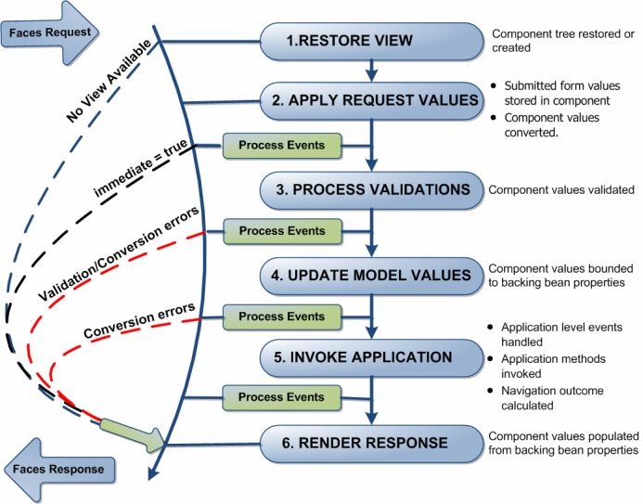

# Pre-Requisites

In order for the application to work it will be necessary to have the following installed on your system. You will need the most current version of NetBeans which can be downloaded from <https://netbeans.org/downloads/index.html>. Once that is installed then the MySQL Community server will need to be downloaded and installed. The download for MySQL can be gotten from <http://dev.mysql.com/downloads/>. Make sure to follow the prompts when installing MySQL and also make not of the user name and password you requested the system create if that was an option that you made.

# Setting up MySQL

In order for the project to make use of the MySQL database it is necessary to make some modifications to the computer that it is running on. These modifications will make MySQL readily available to the user and the application.

1. Download and Install MySQL. Follow the steps for a standard installation.
2. One the Type and Networking page of the installation make sure the “Show advance options” box is checked.
3. On the Accounts and Roles page enter in a password for the root user. Make sure to write that down as we will be using it later.
4. Continue to hit the next button until you get to the Apply Server Configuration page. On this page hit the execute button.
5. Once that is all completed we then need to set up the environment so that MySQL can be launched from a command line.
   1. Right-click the windows button. 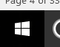
   2. Select system from the list. 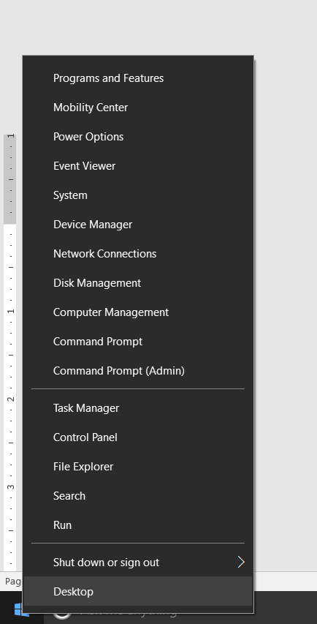
   3. Select advance system settings from the available options. 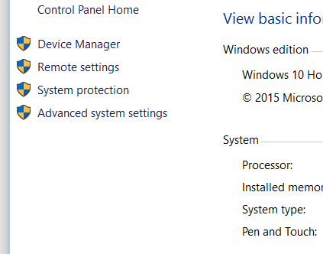
   4. Select the environments variables from the advance tab. 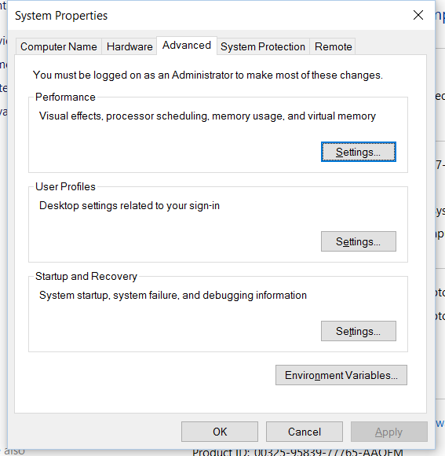
   5. Click on the new button. Then in the variable name put PATH and then for the value put c:\program files\MySQL\MySQL Server 5.7\bin. Then click the ok button. It should look like the following. 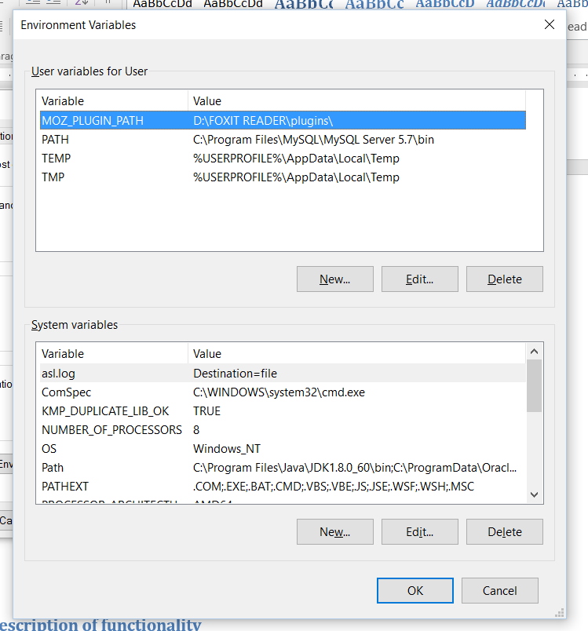
   6. Hit OK on all of the screens to close them out.

# Setting up the IT351sales Database

In order to access the database and the data that is in the database it needs to be first set up before the application can be used.

1. Right-click the windows button. 
2. Select command prompt from the list. 
3. Navigate to the location of the IT351salesbuild.txt file which will probably by the download directory. 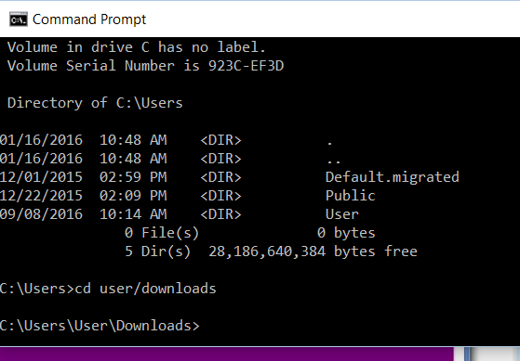
4. Launch MySQL by typing in MySql -u root -p. You will then be prompted to enter in the root passowrd. Remember this is the passowrd you created for the root back when you installed MySql. 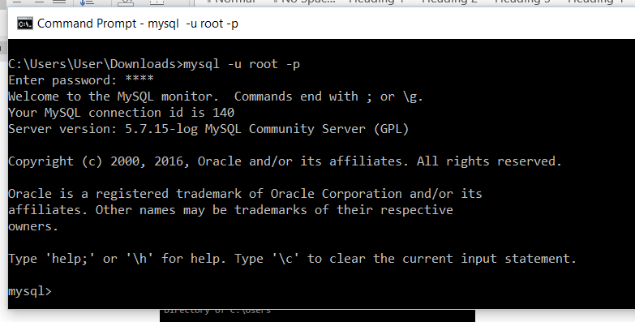
5. Type in source IT351salesbuild.txt; This will create the database and all of the necessary items for the project to work. 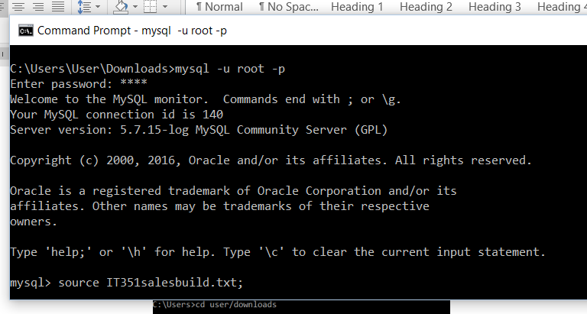
6. Type exit to exit out of MySql and then close the comand prompy window.

# Load Application into NetBeans

The next step is to simply load the project and all of its folders into NetBeans. Once this is completed the application can then be run and the application will then be able to access the information that is in the database.

1. Open NetBeans
2. Click on the Open Project icon. 
3. Locate the IT351jsf project. Select it and click the Open Project button.
4. Click on the Run Project button. 
5. The application will then execute the startup process. The application will first compile and execute the application in the background. It will then establish a connection with the database. All of this will then be passed over to the Glassfish Web Server which will collect all of the components. Build the application and “register” it and then launch the application in the web browser of the user’s choice.

# Using the application

Once the application is open and displayed in the web browser the user can then interact with the user interface and make changes to the database. It’s important to note that NetBeans MUST be running in the background as it is supplying the webserver. The beginning screen is as follows:

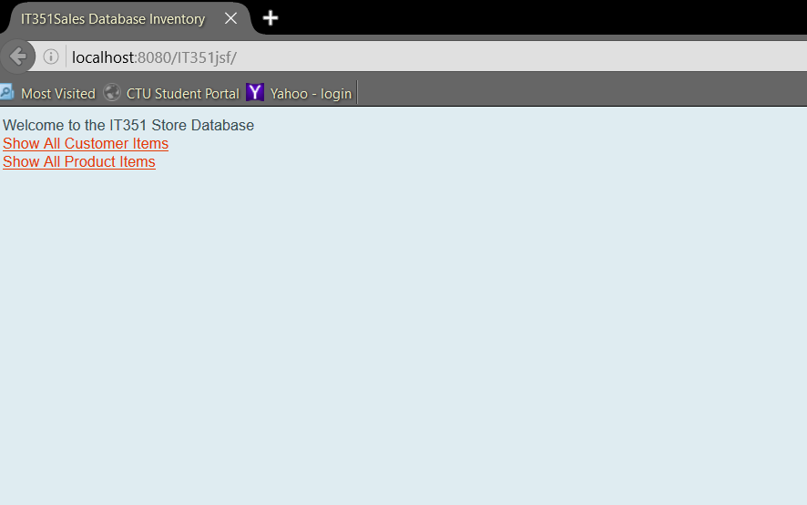

These are the tables that can be interacted with.

From here the use can access each of the tables independently. Once a selection has been made from the home page the user can then interact with the database table of choice directly. The following is what the user will see when they select one of the tables.

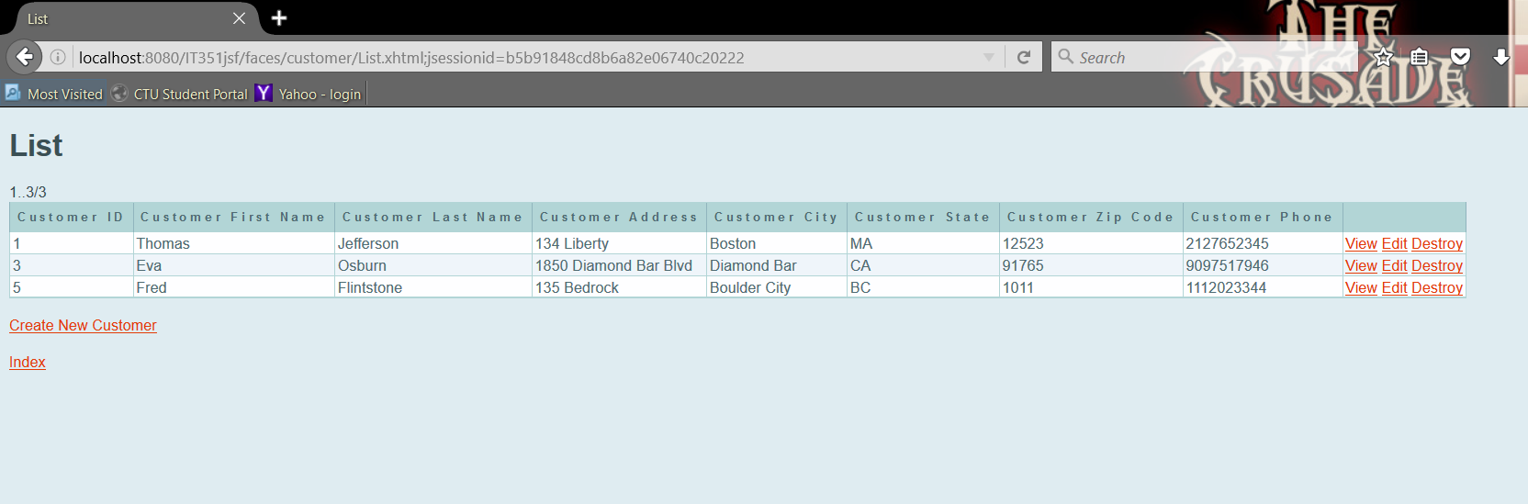

The screen shows the current contents of the database table. From here the user will be able to do any of the CRUD functions. If you notice each line in the list has three available options. View is to view the details of the record. Edit is if the user wants to make a change to the record. Destroy is if the user wants to remove the record from the database permanently. Also you will note there is a “Create New Customer” option at the bottom of the screen. This will allow the user to enter in a new record into the database. The Index option will return the user to the list of the database tables.

## View of Create Record window

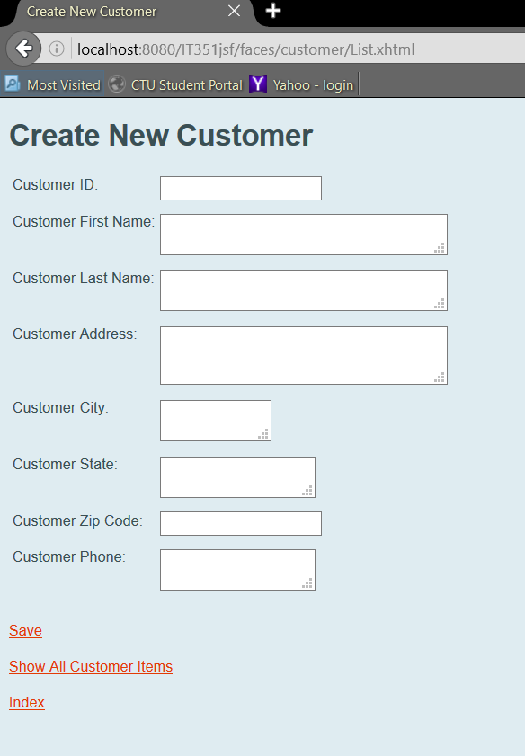

Enter in the information and then hit the save button in order to save the record to the database. Show All Customer Items returns the user to the database table listing. Index returns the user to the database table listing.

## View of Edit Record window

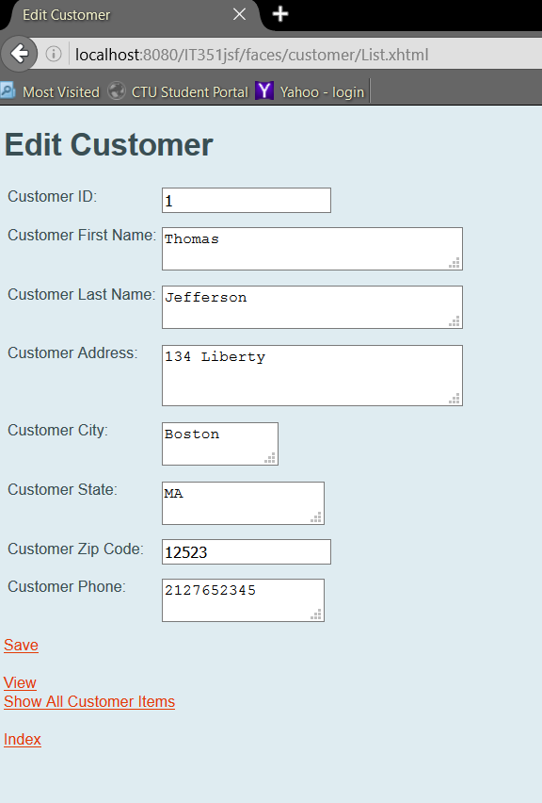

Change what information you want and then hit the save button in order to save the record to the database. Show All Customer Items returns the user to the database table listing. Index returns the user to the database table listing. View takes the user to the view window for the record.

## View of View Record window

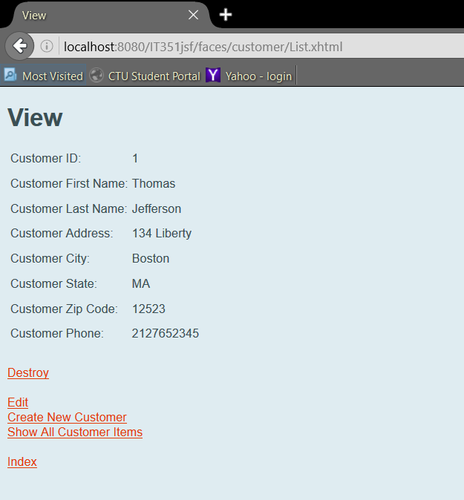

This simply displays the information for that row in the database. If you select Destroy then the record will be deleted from the record. If you select Edit you will be taken to the edit window where you can make changes to the record. The Create New Customer if selected will take the user to the new entry window to enter a new record into the database. Show All Customer Items returns the user to the database table listing. Index returns the user to the database table listing.

**Note: The windows for the product table have the same functionality. The only difference is the titles that are displayed which corresponds to the database table’s columns.**

# Exit the application

In order to exit the application all, you need to do is to close NetBeans. However, if NetBeans is still running but the web browser has been closed. The user can always get back to the application by launching their browser and typing localhost:8080/IT351jsf in the address line.